AI-Powered Personalized Wealth Advisor – Product Requirements Document

Product Overview
The AI Wealth Advisor is a web-based platform offering young professionals (ages 22–35) a friendly, personalized investment advisor experience. It uses a conversational AI (chatbot) interface to answer questions and guide users through financial planning, automatically tailoring advice to each user’s goals, risk tolerance, and time horizon[1][2]. The application supports building and managing a mock portfolio of ETFs, index funds, blue-chip stocks and selected cryptocurrencies, using real-time market data feeds (e.g. Alpha Vantage, Yahoo Finance) to keep asset quotes and charts up to date[3][4]. Users can securely log in via Supabase and create personal profiles that store their financial goals. Visual dashboards display asset allocations, performance trends and progress toward savings goals. By embedding investment education content and interactive tools, the product empowers beginners to learn as they invest[5][6]. The goal is to showcase a fully-developed full-stack project (React front end, Python back end, Supabase database) with clear relevance to real-world fintech.

Goals
- Democratize Investing: Offer an easy, low-cost entry point to wealth management for younger users. Robo-advisors have historically attracted millennials and novices by providing user-friendly interfaces and low minimums[2][6]. Our app aims to extend that by adding an intelligent chat advisor and education.
- Personalized Guidance: Use AI to deliver tailored investment plans and explanations. By analyzing user data, the advisor can create customized financial plans and asset allocations aligned with each user’s objectives and risk profile[1][7].
- 24/7 Interactive Support: Provide an always-available chatbot so users can ask finance questions anytime. Modern conversational AI in finance has proven to improve user engagement and experience[8][9].
- Technical Showcase: Demonstrate full-stack competency using React.js (frontend), Python (backend), and Supabase (database/auth), integrating third-party services (market APIs, LLMs).
- Real-World Viability: Ensure financial realism (market data, risk modeling) and trust (secure login, regulatory compliance features) so the project stands up to scrutiny by financial industry leaders.

Target Users
- Young Professionals (22–35): Tech-savvy beginners with limited investing experience who seek guidance. Studies show robo-advisors appeal to tech-comfortable younger investors with simple interfaces[2][5].
- Novice and Emerging Investors: Users who understand basic goals (retirement, home purchase) but need advice on how to allocate savings. They value clear explanations and educational support.
- Risk-Conscious Savers: Individuals concerned about volatility and looking for moderate portfolios. The product will explicitly assess and match their risk tolerance.
- Time-Constrained Learners: Busy professionals who prefer bite-sized learning (micro-lessons, tooltips) and conversational guidance over traditional reading[5].

Key Features
- Conversational AI Advisor: An NLP-powered chat interface (using an LLM or chatbot framework) that answers investment questions and guides users through tasks. The chatbot will be available 24/7, reflecting industry trends where AI chatbots improve consumer finance experiences[8][9].
- Personalized Recommendations: After onboarding (via a questionnaire on income, goals, risk tolerance, time horizon), the system generates a recommended asset allocation. It will suggest a mix of ETFs, index funds, blue-chip stocks (and optional crypto) suited to the user’s profile[1][10]. The app will periodically rebalance the portfolio model to maintain targets, leveraging AI-driven risk analysis[11].
- Portfolio Management Dashboard: Users can view a visual breakdown of their portfolio (e.g. pie chart of asset allocation, summary stats) and performance trends (line graph of portfolio value over time). The dashboard updates with live data from market APIs, keeping metrics current[12][13].
- Investment Education: Built-in tutorials, tooltips and conversational explanations help demystify investing concepts. For example, the AI can explain terms like “ETF”, “diversification”, or “compound interest” on demand. Embedding education in the app builds trust and empowers users to make smarter decisions[5].
- Real-Time Market Data: Integration with stock/crypto data feeds (e.g. Alpha Vantage’s free APIs[3] and Yahoo Finance via yfinance[4]) provides up-to-date prices and market news. This ensures portfolio valuations and advice reflect current market conditions.
- Secure User Authentication: Use Supabase Auth for robust signup/login (email/password or OAuth). Each user has a protected profile storing their financial data and preferences. We will employ best practices (hashed passwords, HTTPS, SOC 2 compliance) to safeguard data.
- Progress Tracking and Goals: Users set savings/investment goals and the app tracks progress. Visual gauges show how close they are to targets, motivating continued saving. Alerts can notify users when milestones are reached or significant market changes occur.
- Regulatory Compliance (RegTech): Although this is a demo app, it will include features like KYC/AML checks or disclaimers to reflect real-world requirements[14][15]. Educating users about risks (e.g. through disclosures) and following data-privacy laws (GDPR/CCPA) will be treated as core requirements.

Tech Stack
- Frontend (React.js): A single-page application built with React, using component libraries (e.g. Material-UI or Chakra UI) for a polished, responsive interface. React’s ecosystem makes it easy to integrate charts (Chart.js or D3) and a chat UI for the conversational advisor.
- Backend (Python): A Python web framework (FastAPI or Flask) will power the API layer. It will handle user authentication (via Supabase), call external APIs, run business logic, and interact with the database. Python is well-suited for AI integrations (e.g. calling OpenAI’s GPT-4 or other LLM APIs for chat responses).
- Database & Auth (Supabase): A hosted Postgres database provided by Supabase will store user profiles, questionnaires, portfolio data and logs. Supabase’s real-time subscriptions feature will allow the frontend to receive instant data updates (e.g. reflecting portfolio value changes)[12]. Supabase Auth will manage secure user signup/login and session management.
- Market Data APIs: Integration with Alpha Vantage (free stock data APIs) and Yahoo Finance (via Python’s yfinance library) for global equity and ETF data[3][4]. These will supply price histories and current quotes for dashboard visuals and recommendations.
- AI/Chat Engines: Use a conversational AI service (such as OpenAI’s GPT-4 or a similar LLM) to power the chatbot. The backend will format user inputs and prompt the LLM to generate friendly, accurate financial advice.
- DevOps and Hosting: The app can be containerized (Docker) and deployed on cloud platforms (e.g. Vercel for React, Heroku or AWS for the Python backend). CI/CD pipelines and environment management will ensure scalability and ease of iteration.

User Stories
- Onboarding & Goal Setting: As a new user, I want to set up my profile with my savings goals (e.g. “buy a house in 10 years”) and risk preference, so that the app can tailor investment suggestions accordingly.
- Interactive Chat Help: As a user with little finance knowledge, I want to ask the AI simple questions (for example, “Should I invest in index funds or individual stocks?”) and get easy-to-understand answers.
- Personalized Planning: As a young professional, I want the app to propose a portfolio based on my situation (e.g. 70% ETFs, 20% bonds, 10% crypto) and explain why it matches my goals.
- Portfolio Tracking: As an investor, I want to view charts of my mock portfolio’s performance and allocation (pie charts, growth graphs) so I can monitor how my investments would be doing.
- Adjusting Plan: As my financial situation changes (e.g. I get a bonus or reduce my risk tolerance), I want to update my profile and see how the recommendations and goals adjust.
- Learning & Education: As a beginner, I want to see brief educational articles or tooltips about terms like “diversification” or “compounding,” so I can learn as I go.
- Secure Access: As a user, I want to securely log in and know that my data (even if simulated) is private, so I trust the service with my information.

Functional Requirements
- User Authentication: Implement secure account creation and login (email/password, with email verification) using Supabase Auth. Protect all sensitive routes.
- Onboarding Questionnaire: A multi-page form collects user data: age, income, investment horizon, goals, risk tolerance. Store this data in the database for personalization.
- AI Chat Module: A live chat window where users type questions. The front end sends user messages to the backend, which queries an AI model. The AI must respond contextually, referencing the user’s profile where relevant. E.g., “Based on your goals, a balanced ETF portfolio could work.”
- Portfolio Builder: Allow users to “add” or “edit” holdings in their virtual portfolio. Provide a catalog of example assets (tickers) to choose from. Calculate portfolio value using real-time prices.
- Recommendation Engine: Based on the user profile, compute an optimal asset allocation. This could use simple rules (e.g. risk score → stock/bond ratio) or a basic optimization algorithm. The recommendations should adjust when inputs change.
- Data Integration: Backend services must fetch market data via APIs. For example, call Alpha Vantage to get daily price data for selected ETFs and stocks. Update stored price snapshots at least once per day or on-demand. Handle API rate limits gracefully.
- Dashboards and Charts: Display data visualizations on the frontend: e.g., a pie chart of asset allocation, line chart of portfolio growth, bar chart of contributions vs. withdrawals. These visuals should update automatically when underlying data changes (using Supabase realtime or manual refresh).
- Goal Tracking: Users can set target goal amounts and dates. The system projects growth (assuming some expected return) and shows a progress bar or projection chart.
- Educational Content Library: Include a section with written guides or FAQs on investing topics. Optionally, the AI chatbot can trigger these articles in conversation.
- Notifications: Implement at least email or in-app alerts for key events (e.g. “Your portfolio has reached 80% of your goal”, or “The AI suggests rebalancing after market shift”).
- Audit Logging: Log significant user actions (e.g. login, profile changes, portfolio edits) for debugging and future improvement.
- Error Handling & Validation: Provide user-friendly validation (e.g. for form inputs) and error messages (e.g. if API call fails or user input is invalid).

Non-Functional Requirements
- Performance & Responsiveness: The UI should feel snappy. Use real-time updates (via websockets) for market data to avoid full page reloads[12]. API responses (especially from the AI or market data sources) should be handled asynchronously with loading indicators. Aim for <2-second response on critical actions.
- Scalability: The app should be designed so it can scale to many users. Supabase and cloud hosting allow seamless scaling. The AI backend should queue requests if needed. As noted for AI wealth advisors, scalability (serving many clients simultaneously) is a key advantage[9].
- Availability: The service (especially the chatbot) should target 24/7 availability with minimal downtime. Use reliable hosting and automated health checks.
- Security & Compliance: All data in transit and at rest must be encrypted (HTTPS, TLS). Follow best practices for authentication and data protection. Comply with relevant regulations: e.g., implement basic KYC/AML flows (validate user identity) and adhere to data privacy laws (GDPR/CCPA)[14][15]. Regularly audit and pen-test the app.
- Accuracy & Reliability: Market data should be as up-to-date as possible. Implement caching appropriately to avoid stale data. Ensure the AI advisor’s information is accurate by validating any financial rules (and always include disclaimers that it is not a human advisor).
- Usability & Accessibility: The interface should be mobile-responsive and intuitive, with clear navigation. Follow WCAG accessibility guidelines so the app is usable by people with disabilities.
- Maintainability: Organize code in modular components and services. Document APIs and data models. Write clean, commented code so future developers (or the user) can understand the architecture. Include unit tests for core logic.
- Localization (Future): While initially in English, design the UI with i18n support for future translation. Support multiple currencies if needed.

Wireframe Descriptions
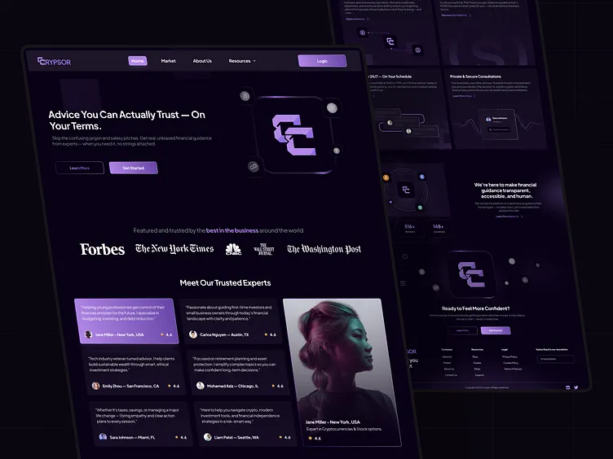
Figure: Example landing page design for an AI wealth advisor emphasizing trust and ease of use. This mockup shows a clean homepage with a prominent headline (e.g. “Personalized Wealth Advice – Anytime, Anywhere”) and a brief description. The top navigation includes links to features and login/signup. Trust elements (logos of publications or badge icons) underscore credibility. A hero section might feature an illustrated advisor character or interactive prompt (“Ask your financial coach!”). The call-to-action buttons invite users to start the chat or sign up. Below the fold (not shown), there could be highlights of key benefits (e.g. “24/7 AI Chat Help”, “Real-Time Portfolio Tracking”) and screenshots of the dashboard.
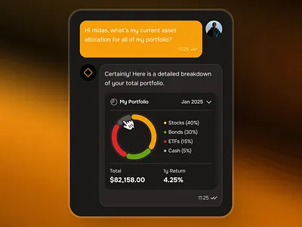
Figure: Chat interface showing a portfolio breakdown answer. This wireframe illustrates the core conversational UI. The user’s question (“What’s my asset allocation?”) appears on the left, and the AI’s reply is on the right. In this example, the AI has returned a pie chart of portfolio composition (stocks, bonds, cash, crypto) along with a brief textual explanation. The design is clean and minimalist, with a side panel that could list metrics (e.g. total value, risk score) or shortcuts. This demonstrates how visual data (charts, graphs) can be seamlessly integrated into the chat flow for clarity.
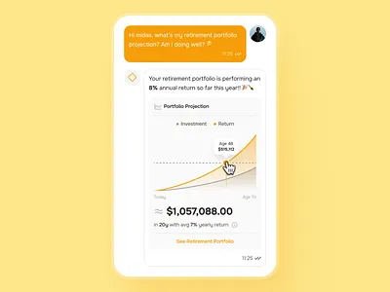
Figure: Chatbot response with a portfolio growth projection. Here the AI has answered a user query by providing a projected growth chart of the portfolio over time. The line graph (in yellow) illustrates how investments may grow given current contributions and assumed returns. Accompanying text can explain the assumptions (“Assuming 7% annual return”). The interface keeps the conversation format, but enriches it with dynamic charts. This wireframe underscores the ability to present predictive analytics (performance trends) in an interactive way, reinforcing the user’s financial education.
Additional Screens (not pictured): The app would include a Signup/Login screen (Supabase-powered form), a Profile/Settings page (where users update goals or risk tolerance), and a Learning Center section with articles or tooltips. A Risk Assessment flow could use sliders or multiple-choice questions to gauge tolerance. All screens maintain the same visual style and branding as the examples above, ensuring a cohesive user experience.
Sources: This PRD incorporates best practices and data from industry sources. For example, robo-advisors are noted to attract tech-savvy younger investors with user-friendly, low-cost solutions[2][6], and embedding educational content is known to increase user empowerment and trust[5]. The use of AI-driven personalized planning and real-time portfolio optimization are drawn from current AI wealth management trends[1][7]. Integration of Supabase (real-time Postgres, secure auth) and free market APIs (Alpha Vantage, Yahoo Finance) reflects practical implementation patterns[12][4]. Regulatory considerations (KYC/AML, privacy laws) are included as essential compliance measures[14][15]. All features are designed with clarity, scalability, and financial realism in mind, in line with the requirements for a professional-grade wealth advisor platform.

[1] [7] [9] [11] [13] AI in Wealth Management: Bridging the Gap Between Technology and Human Expertise
https://www.hashstudioz.com/blog/ai-in-wealth-management-bridging-the-gap-between-technology-and-human-expertise/
[2] [6] What Is a Robo-Advisor? Definition, Myths and Uses
https://www.investing.com/academy/trading/what-is-a-robo-advisor/
[3] Alpha Vantage: An Introduction to a Highly Efficient Free Stock API | by Nikhil Adithyan | CodeX | Medium
https://medium.com/codex/alpha-vantage-an-introduction-to-a-highly-efficient-free-stock-api-6d17f4481bf
[4] GitHub - ranaroussi/yfinance: Download market data from Yahoo! Finance's API
https://github.com/ranaroussi/yfinance
[5] In today’s competitive fintech landscape, investment education campaigns are vital to bridge the gap between your app’s sophisticated offerings and users’ financial literacy. For mobile app designers and product managers, this means crafting onboarding experiences that translate complex investment concepts into clear, approachable journeys tailored to diverse user segments.
https://www.zigpoll.com/content/how-can-we-design-an-intuitive-onboarding-flow-that-simplifies-complex-investment-concepts-for-beginner-users-in-our-mobile-app-campaign
[8] Using AI to Improve Customer Experiences in Finance | Deloitte US
https://www.deloitte.com/us/en/what-we-do/capabilities/applied-artificial-intelligence/articles/ai-dossier-financial-services.html
[10] [15] What is a fintech app? Here’s what to know | Stripe
https://stripe.com/in/resources/more/what-is-a-fintech-app-types-and-how-businesses-use-them
[12] Realtime - Postgres changes | Supabase Features
https://supabase.com/features/realtime-postgres-changes
[14] Fintech Compliance: How to Build Regulation-Ready Apps
https://openforge.io/fintech-compliance-navigating-financial-app-regulations/

